# Linux Environment Variable Assignment

1. State the command for the following.
   1. view current environment variables

pwd

set

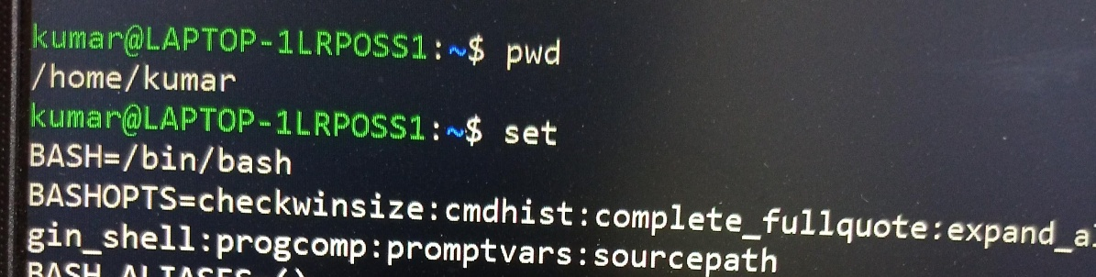

* 1. display the PATH evirnment variable value

echo $PATH

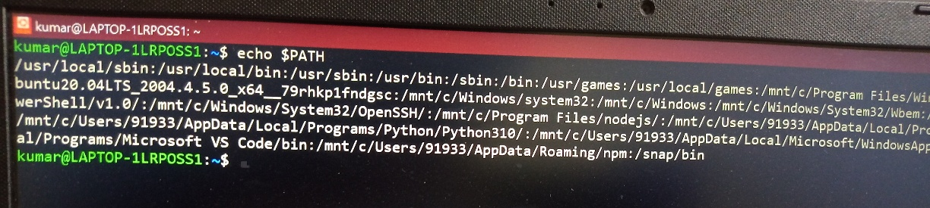

* 1. update PATH to include the path to your home directory

PATH=$PATH:/home/kumar

Echo $PATH

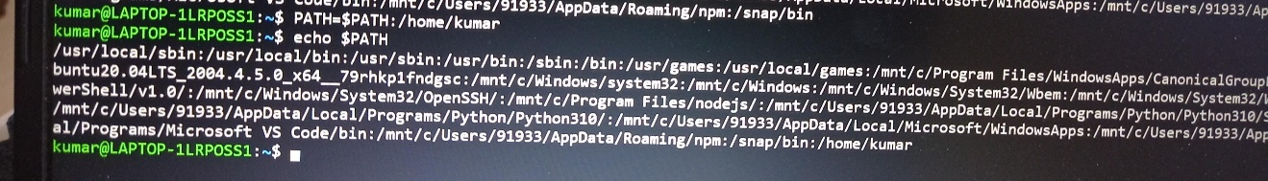

1. How will you make the environment changes applicable to all users? Which script is to be modified?

To make changes to the environment variables for all new accounts, go to your /etc/skel files, such as . bashrc , and change the ones that are already there or enter the new ones.

1. I have installed an application named “myapp”. After installation, if I invoke the application, it fails with error as “Command myapp not found”. How will you fix this?